ASSIGNMENT -9

Q-1)Write a query that lists each order number followed by the name of customer who made the order.

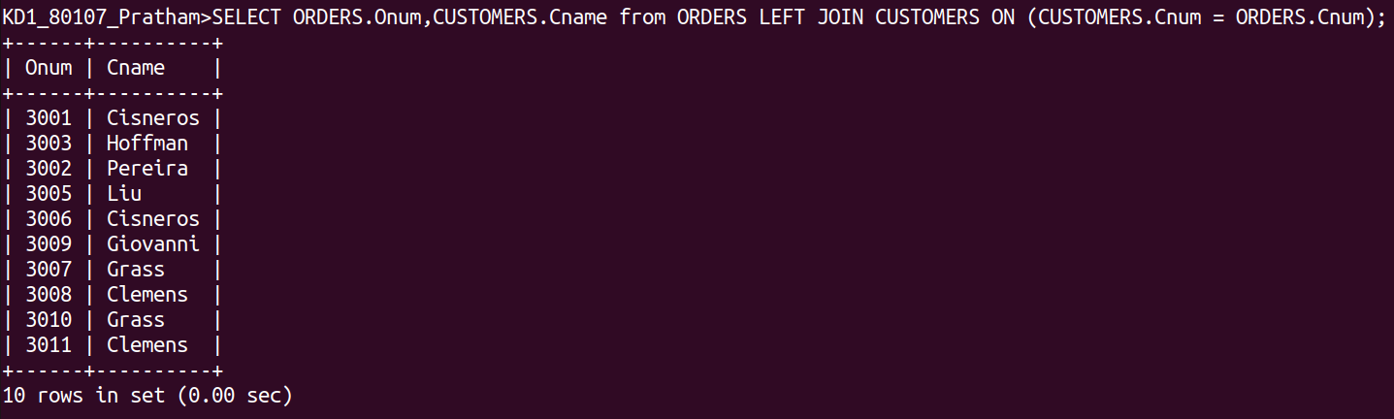
Q-2)Write a query that gives the names of both the salesperson and the customer for each order along with the order number.

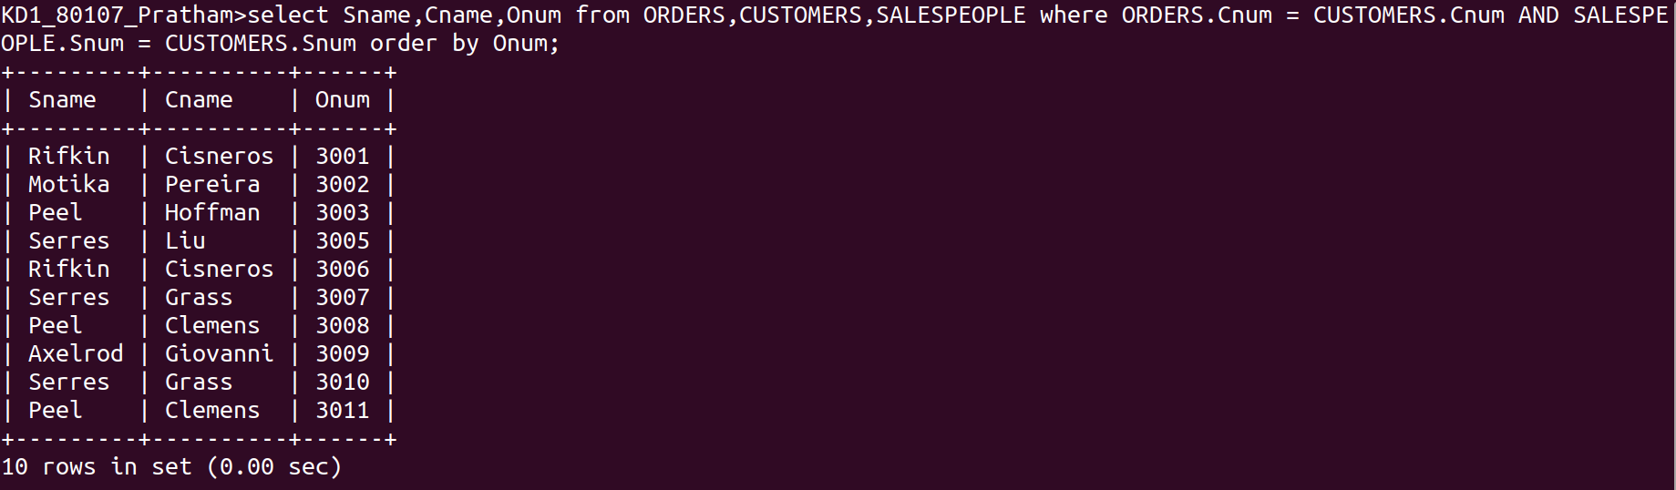

Q-4) Write a query that calculates the ammount of the salesperson’s commission on each order by a customer with a rating above 100.
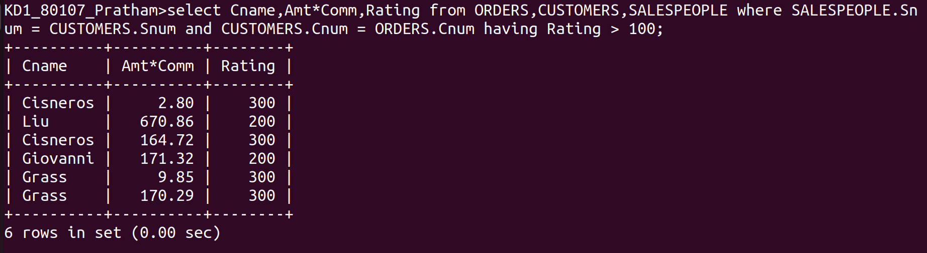

Q-3 write a query that produces all customers serviced by salespeople with a commission above 12%. Output the customer’s name,the salesperson’s name, and the salesperson’s rate of commission.
